Task Analysis [TA] + Emergency Rescue / Response Plan SSSP Form 10
Task Analysis [TA]
Tick one – is a translator required? Tick one – is an Emergency Rescue/Response Plan attached?
☐ Yes ☐ No ☐ Yes ☐ No
Site name PCBU2 Company Name PCBU2 Site Contact Information
Task Analysis sign-on
All workers involved in the task must sign this register to show that they have been consulted in the processes and will work to the requirements of this TA.
Worker Name | Worker signature |  | Worker Name | Worker signature
 |  |  | Works Supervisor Name | Works Supervisor signature
Work method statement
Describe the activity and how it will be carried out. Where possible, identify the individuals who will be carrying out the task/s and their roles in it.
Task Analysis [TA] + Emergency Rescue / Response Plan SSSP Form 10
Task Analysis [TA]
Identify PPE to be used
NOTE: PPE may be used in conjunction with other methods of control but must never be the only method of control. Place a tick next to each item to be used as part of the control process.
☐ ☐ ☐ ☐ ☐ ☐ ☐ ☐ 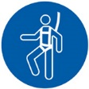 ☐ Other
Sequence of basic steps  Describe each step in the activity – most  will have 4-8 steps. Follow the flow of the  product or process | Potential hazards and risks  Describe the key hazards and risks for each step – there will  normally be more than one per step. |  | Initial risk  What would the risk  level be without  controls? Refer to the  risk assessment matrix | Control methods and level of control  Describe the method/s that will be used to control the risk  (refer to the hierarchy of controls for guidance) | Hierarchy of  Control Level | Residual risk  What is the risk level  after controls are in  place? Refer to the risk  assessment matrix
Step 1 | 1a
 | 1b
 | 1c
 | 1d
Task Analysis [TA] + Emergency Rescue / Response Plan SSSP Form 10
Task Analysis [TA]
Identify PPE to be used
NOTE: PPE may be used in conjunction with other methods of control but must never be the only method of control. Place a tick next to each item to be used as part of the control process.
☐ ☐ ☐ ☐ ☐ ☐ ☐ ☐ ☐ Other
Sequence of basic steps  Describe each step in the activity – most  will have 4-8 steps. Follow the flow of the  product or process | Potential hazards and risks  Describe the key hazards and risks for each step – there will  normally be more than one per step. |  | Initial risk  What would the risk  level be without  controls? Refer to the  risk assessment matrix | Control methods and level of control  Describe the method/s that will be used to control the risk  (refer to the hierarchy of controls for guidance) | Hierarchy of  Control Level | Residual risk  What is the risk level  after controls are in  place? Refer to the risk  assessment matrix
Step 2 | 2a
 | 2b
 | 2c
 | 2d
Task Analysis [TA] + Emergency Rescue / Response Plan SSSP Form 10
Task Analysis [TA]
Identify PPE to be used
NOTE: PPE may be used in conjunction with other methods of control but must never be the only method of control. Place a tick next to each item to be used as part of the control process.
☐ ☐ ☐ ☐ ☐ ☐ ☐ ☐ ☐ Other
Sequence of basic steps  Describe each step in the activity – most  will have 4-8 steps. Follow the flow of the  product or process | Potential hazards and risks  Describe the key hazards and risks for each step – there will  normally be more than one per step. |  | Initial risk  What would the risk  level be without  controls? Refer to the  risk assessment matrix | Control methods and level of control  Describe the method/s that will be used to control the risk  (refer to the hierarchy of controls for guidance) | Hierarchy of  Control Level | Residual risk  What is the risk level  after controls are in  place? Refer to the risk  assessment matrix
Step 3 | 3a
 | 3b
 | 3c
 | 3d
Task Analysis [TA] + Emergency Rescue / Response Plan SSSP Form 10
Task Analysis [TA]
Identify PPE to be used
NOTE: PPE may be used in conjunction with other methods of control but must never be the only method of control. Place a tick next to each item to be used as part of the control process.
☐ ☐ ☐ ☐ ☐ ☐ ☐ ☐ ☐ Other
Sequence of basic steps  Describe each step in the activity – most  will have 4-8 steps. Follow the flow of the  product or process | Potential hazards and risks  Describe the key hazards and risks for each step – there will  normally be more than one per step. |  | Initial risk  What would the risk  level be without  controls? Refer to the  risk assessment matrix | Control methods and level of control  Describe the method/s that will be used to control the risk  (refer to the hierarchy of controls for guidance) | Hierarchy of  Control Level | Residual risk  What is the risk level  after controls are in  place? Refer to the risk  assessment matrix
Step 4 | 4a
 | 4b
 | 4c
 | 4d
Task Analysis [TA] + Emergency Rescue / Response Plan SSSP Form 10
Task Analysis [TA]
Identify PPE to be used
NOTE: PPE may be used in conjunction with other methods of control but must never be the only method of control. Place a tick next to each item to be used as part of the control process.
☐ ☐ ☐ ☐ ☐ ☐ ☐ ☐ ☐ Other
Sequence of basic steps  Describe each step in the activity – most  will have 4-8 steps. Follow the flow of the  product or process | Potential hazards and risks  Describe the key hazards and risks for each step – there will  normally be more than one per step. |  | Initial risk  What would the risk  level be without  controls? Refer to the  risk assessment matrix | Control methods and level of control  Describe the method/s that will be used to control the risk  (refer to the hierarchy of controls for guidance) | Hierarchy of  Control Level | Residual risk  What is the risk level  after controls are in  place? Refer to the risk  assessment matrix
Step 5 | 5a
 | 5b
 | 5c
 | 5d
Task Analysis [TA] + Emergency Rescue / Response Plan SSSP Form 10
Task Analysis [TA]
Identify PPE to be used
NOTE: PPE may be used in conjunction with other methods of control but must never be the only method of control. Place a tick next to each item to be used as part of the control process.
☐ ☐ ☐ ☐ ☐ ☐ ☐ ☐ ☐ Other
Sequence of basic steps  Describe each step in the activity – most  will have 4-8 steps. Follow the flow of the  product or process | Potential hazards and risks  Describe the key hazards and risks for each step – there will  normally be more than one per step. |  | Initial risk  What would the risk  level be without  controls? Refer to the  risk assessment matrix | Control methods and level of control  Describe the method/s that will be used to control the risk  (refer to the hierarchy of controls for guidance) | Hierarchy of  Control Level | Residual risk  What is the risk level  after controls are in  place? Refer to the risk  assessment matrix
Step 6 | 6a
 | 6b
 | 6c
 | 6d
Task Analysis [TA] + Emergency Rescue / Response Plan SSSP Form 10
Task Analysis [TA]
Identify PPE to be used
NOTE: PPE may be used in conjunction with other methods of control but must never be the only method of control. Place a tick next to each item to be used as part of the control process.
☐ ☐ ☐ ☐ ☐ ☐ ☐ ☐ ☐ Other
Sequence of basic steps  Describe each step in the activity – most  will have 4-8 steps. Follow the flow of the  product or process | Potential hazards and risks  Describe the key hazards and risks for each step – there will  normally be more than one per step. |  | Initial risk  What would the risk  level be without  controls? Refer to the  risk assessment matrix | Control methods and level of control  Describe the method/s that will be used to control the risk  (refer to the hierarchy of controls for guidance) | Hierarchy of  Control Level | Residual risk  What is the risk level  after controls are in  place? Refer to the risk  assessment matrix
Step 7 | 7a
 | 7b
 | 7c
 | 7d
Task Analysis [TA] + Emergency Rescue / Response Plan SSSP Form 10
Task Analysis [TA]
Identify PPE to be used
NOTE: PPE may be used in conjunction with other methods of control but must never be the only method of control. Place a tick next to each item to be used as part of the control process.
☐ ☐ ☐ ☐ ☐ ☐ ☐ ☐ ☐ Other
Sequence of basic steps  Describe each step in the activity – most  will have 4-8 steps. Follow the flow of the  product or process | Potential hazards and risks  Describe the key hazards and risks for each step – there will  normally be more than one per step. |  | Initial risk  What would the risk  level be without  controls? Refer to the  risk assessment matrix | Control methods and level of control  Describe the method/s that will be used to control the risk  (refer to the hierarchy of controls for guidance) | Hierarchy of  Control Level | Residual risk  What is the risk level  after controls are in  place? Refer to the risk  assessment matrix
Step 8 | 8a
 | 8b
 | 8c
 | 8d
Task Analysis [TA] + Emergency Rescue / Response Plan SSSP Form 10
Using the Risk Assessment Matrix and Hierarchy of Controls
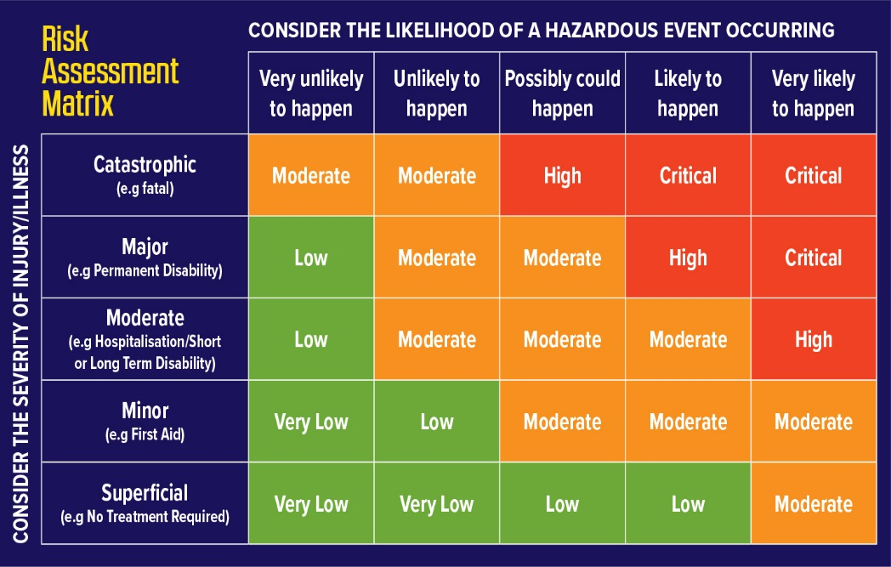  1. Determine risk by identifying the potential harm (horizontal rows).  2. Then choose the most realistic likelihood (vertical columns)  3. Where the two converge is the “Risk Level” for that situation.  4. Use the Control Hierarchy to guide the selection of control methods that will be applied  5. The risk level after controls MUST be significantly lower than the risk level without controls.  6. If the controls do not provide an acceptable level of risk reduction, the risk process must be repeated until the level is safe.  7. If the hazard itself cannot be completely removed (Elimination) then the focus must be on reducing severity or decreasing likelihood (or both) so as to reduce the risk level from what it originally was.  8. If the risk level cannot be sufficiently reduced, the entire activity must be reviewed and replanned until a safer alternative methodology is devised. |  | 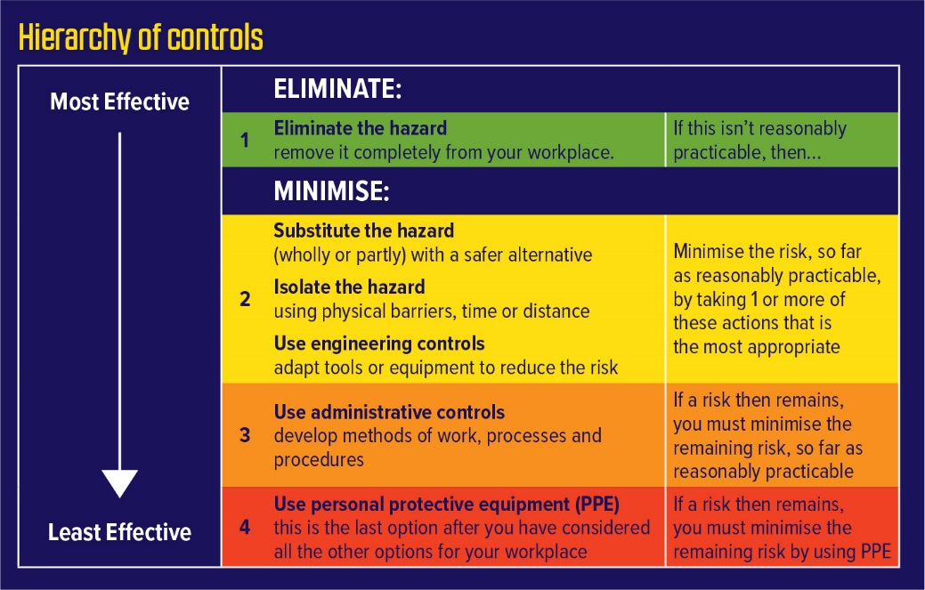  1. Applying the control hierarchy is the required method to provide an effective control to a hazard or high risk situation.  2. The most effective solutions are in sections 1 & 2 of the list. The reason they are effective is because they deal directly with the problem.  3. The least effective (sections 3 & 4) are weaker solutions because they rely heavily on people remembering to do something.  4. Neither section 3 or 4 should be used in isolation. On their own, neither of these have any effect on the actual problem.  5. Ultimately the solution should be a combination of sections 1 & 2 with assistance from sections 3 & 4.  6. Note that elimination does not necessarily mean eliminate the entire hazard, although that would be preferable. Elimination of parts of the problem may still significantly reduce the overall risk level. Consider the severity of injury/illness

Date |  |  |  |  |  |  |  |  |  |  | Company
 |  | / |  |  | /
Task Analysis [TA] + Emergency Rescue / Response Plan SSSP Form 10
Emergency Rescue / Response Plan
You need to have a response plan to deal with any incidents that may require a rescue or containment or other emergency response as identified in the Site-Specific Safety Plan Agreement.
Please complete an Emergency Rescue/Response Plan for each identified activity. The subcontractor (PCBU 2) completes the plan, which does not replace any overarching Emergency Rescue/Response Plans put in place by the Main Contractor (PCBU 1). Consider the roles and responsibilities for yourself, trained specialists, equipment operators, and emergency services.

Describe type of emergency e.g. Fall from height while wearing a harness
Describe work activity e.g. Working from MEWP and fall off
Describe the rescue method e.g. Safety watcher on the ground releases the bleed valve, and
lowers the unit to the ground

Location
Main Contractor/Principal Company
Supervisor Date
 |  |  |  | / |  |  | /
List any equipment required e.g. MEWP, cherry picker, scissor lift, ladder, breathing apparatus etc.

Name each person involved in the response  First name and last name | Their role or responsibility in the response is to  e.g. release the bleed valve | List the training required  e.g. competence using MEWP | Provide contact details  Phone number

